ELEMENTARY PRINCIPLES OF CHEMICAL PROCESSES
ERRATA – 4th EDITION TEXT
Updated 5/23/2026

If you have a later printing or are using the eTextbook,
these errors may have already been corrected.

Digital Resources and WileyPLUS
- The author-maintained website address should be http://epcp.wordpress.ncsu.edu
Selected Tables and Figures
- Factors for Unit Conversions
- Conversion factor table, under Pressure units: on the second line there should be “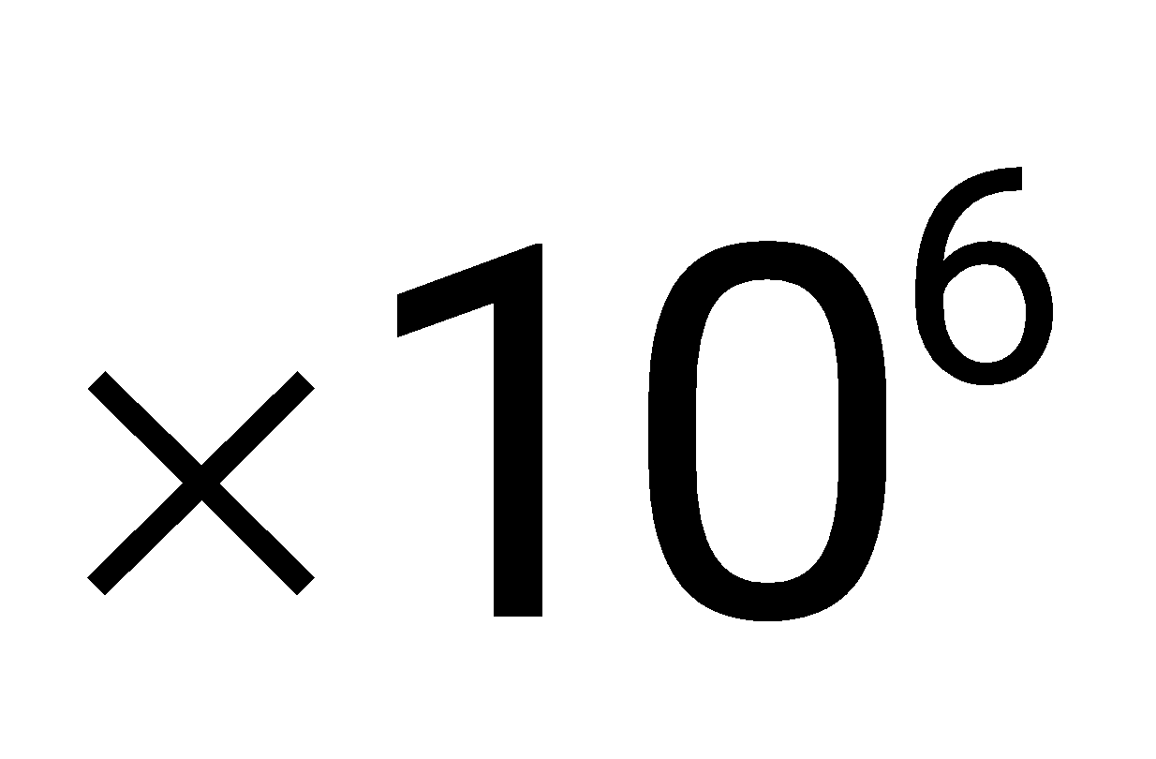” before “dynes/cm²”.
- Conversion factor table, under Pressure units: on the fourth line, the factor should be “= 406.8 inches H₂O (l) at 4ºC”.
CHAPTER 2
- Section 2.3: In 3(b) (Derived units), the first equivalency term on the right hand side should read 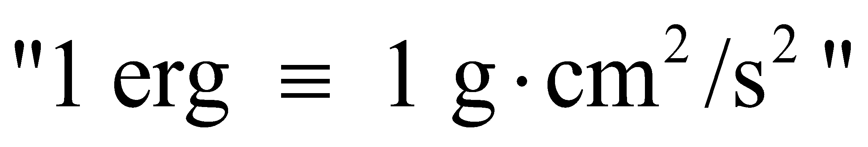.
- Problem 2.13: Replace the text for part (b), with the following: “Suppose you decide to install the 240W panels, and the average cost of electricity purchased over the next three years is $0.15/kWh. You can sell back "extra" electricity (the amount of electricity which the solar panels produce over and above your monthly requirement) to the utility for $0.15/kWh. What would the total cost "savings" be for the utility "sell back" over that 3-year period? What more would you need to know to determine whether the investment in the solar panels would pay off?”

CHAPTER 3

- Section 3.3d, Test Yourself: The answers should be:
1. 68 x 10⁻⁶ kg creatinine/kg blood (or g/g or lb_{m}/ lb_{m})
2. 68 mg creatinine
3. 0.0721 g creatinine/L blood (blood density = 1060 kg/m³)
- Problem 3.4: The answer should be $140 instead of $154.
- Problem 3.13: In the problem statement, part (a), insert the phrase “(assume it’s rectangular)” at the end of the first sentence.
- Problem 3.16: The answer should be “(c) 0.63”
- Problem 3.30:
  - In the problem statement, the first line should have the word “Wet” inserted at the beginning: “Wet coal being used….” Below the weight % table, the first sentence should be replaced with, “The wet coal contains 4.58 lb_{m} H₂O per lb_{m} of dry coal.”
  - The answer should be 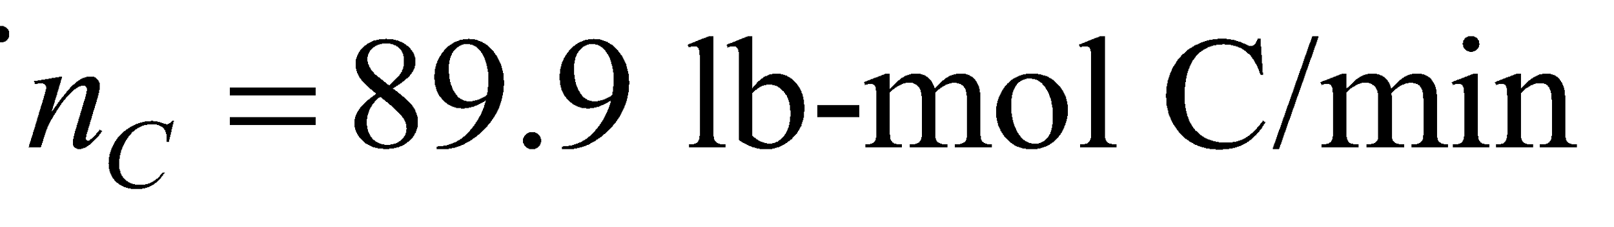
- Problem 3.37: In the problem statement, the units in the table should be “Million Metric Tons C”, not “Metric Tons C”.

CHAPTER 4

- Section 4.3a: In the italicized paragraph, line 1, change “kilograms” to “pounds”.
- Section 4.6a: In the second equation above the “Test Yourself” block, in the numerator of the third term, it should say “1 kmol O₂ consumed”, not “1 kmol O₃ consumed”.
- Section 4.6b: Below Equation 4.6-4, in both of the hydrogen balances (2 instances), it should read “300 mol H₂/s”, not “300 mol N₂/s”
- Section 4.6b, Test Yourself: The last response should be 40 (delete “kmol”).
- Section 4.6d: In the paragraph under the third equation, 5th line, “methane and propane” should be “methane and propylene”
- Section 4.6d, Test Yourself: Question 4: the response should be “80, 10” (delete “mol”).
- Section 4.7a: For the atomic C balance, the equation underneath the vertical arrow should read “200 kmol C/min = 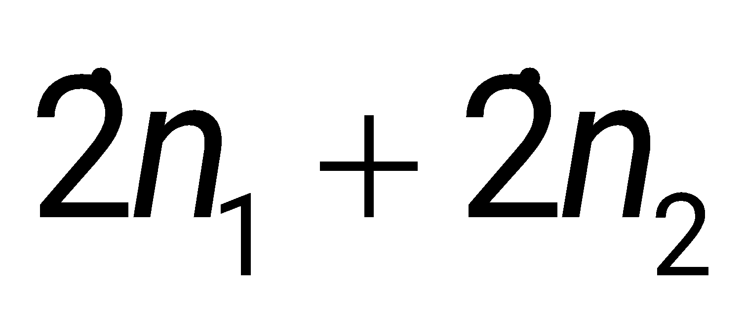”
  - Section 4.7e, Test Yourself, Question 3:
  - Remove the “mol” unit from each extent of reaction answer 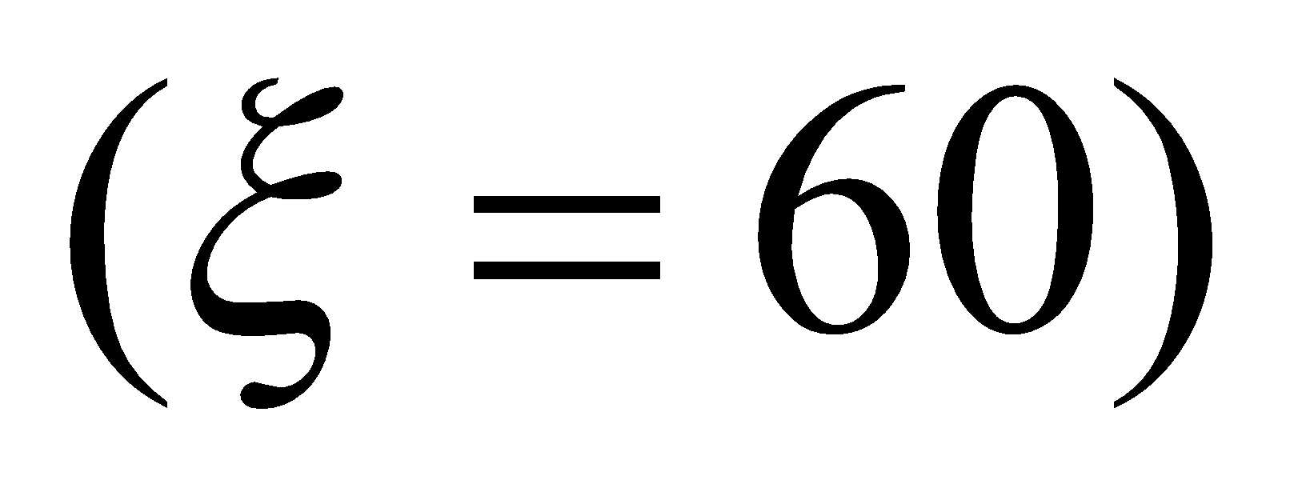, 3 instances.
  - Show each of the equations on a separate line so that they don’t run together:
40 mol CH4 = 100 mol CH4−ξ ⇒ ξ=60
130 mol O2 = 250 mol O2−2ξ ⇒ ξ=60
60 mol CO2 = 0 mol CO2+ξ ⇒ ξ=60
- Section 4.7e, Example 4.7-1 Solution:
  - In the O₂ Balance, the general mass balance equation for O₂ should say: "Output = Input - Consumption" instead of "Output = Generation - Consumption".
  - In the next-to-last sentence of the solution, replace “Once again the same flow rates have been calculated,” with “Once again the same molar amounts have been calculated,”.
  - In the line under equation (2), the end of the sentence should read “…yields the following five extent of reaction balances [(3) – (7)] in five….”.
  - Equation (5) should read 8n_{CO} (= n_{CO2}) = (1 mol CO₂)ξ₂
- Problem 4.2: The answer should be “4.1667 L/s”
- Problem 4.5: In the problem statement, part (a), line 2, the units of 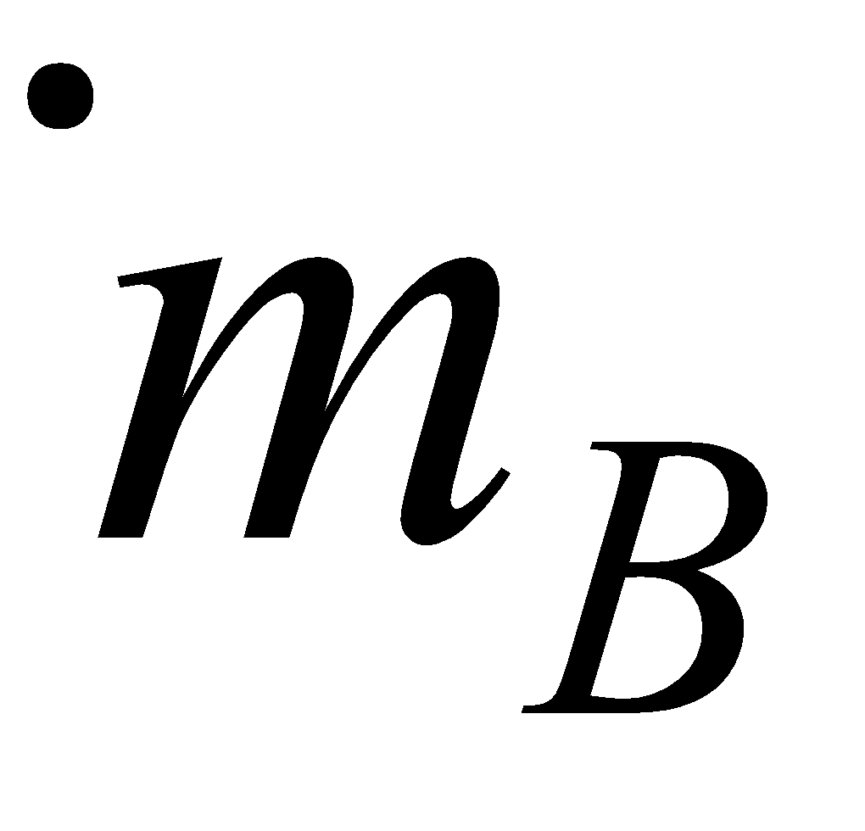 should be (g C₆H₆/s).
- Problem 4.6: The answer should be for (a) instead of (b)
- Problem 4.19: In the problem statement, on the second line of part (a), replace the word “feed” with “aqueous serine solution”. The second line of part (b) should say “required feed rates of aqueous serine solution and methanol.”
- Problem 4.36: In the problem statement, in the list of data provided, R(SO₂ analyzer) for the outlet gas should be 11.6, not 116.
- Problem 4.43: In the problem statement, part (c), the third line should say “65%” instead of “58%”.
- Problem 4.46: In the problem statement, second paragraph, line 6, it should say "20.0 kg" instead of "2.0 kg".
- Problem 4.48: In the problem statement, the second sentence should say "The feed ratio to the extractor is 3 kg hexane/kg beans".
- Problem 4.66: The answer should be “(e) 0.795 mol A reacted/mol A fed”
- Problem 4.80:
  - Replace the problem statement of part (a) with the following: “For a methanol production rate of 100 kmol/h, calculate the fresh feed rate (kmol/h), the molar flow rate and composition of the purge gas, and the overall and single-pass conversions.”
  - The answer should be “(a) Overall conversion: 76%”
- Problem 4.82: The answer should be 260.4 kmol C₈H₁₈/h.
- Problem 4.90:
  - In the problem statement, change the CO₂ mole% to 24.5% and the CO mole % to 6.10%.
  - The answer should be “(a) 49% excess O₂”.
  - Problem 4.96: The answer should be “10.7% CO₂”.

CHAPTER 5

- Section 5.2c, Example 5.2-5: In the solution, in the degree of freedom analysis, third line, it should say “(overall, C₃H₆O)”
- Section 5.3b: In the line under equation 5.3-2, the equation should be 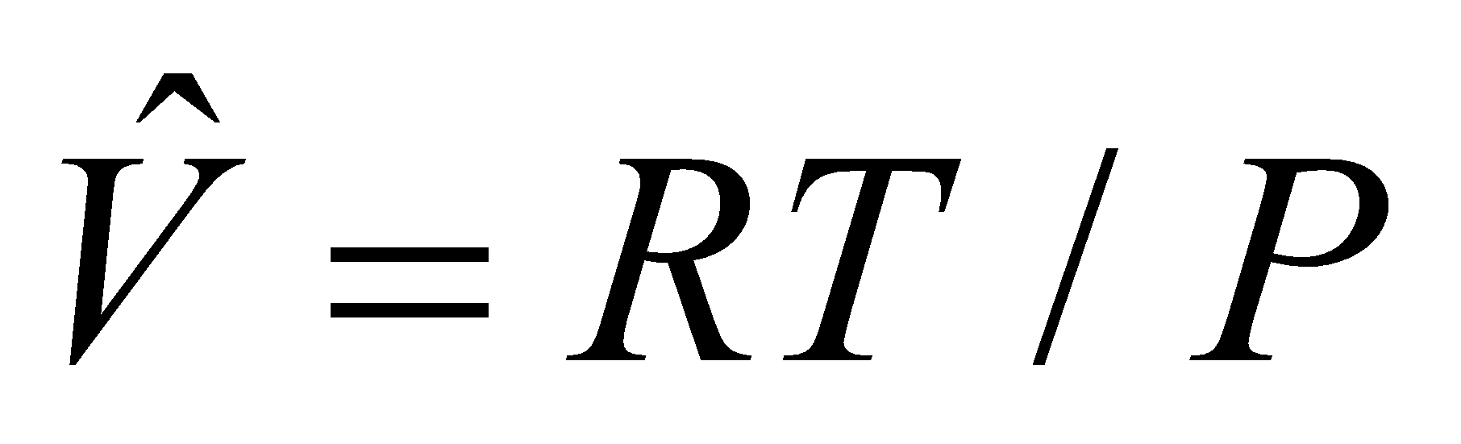, not 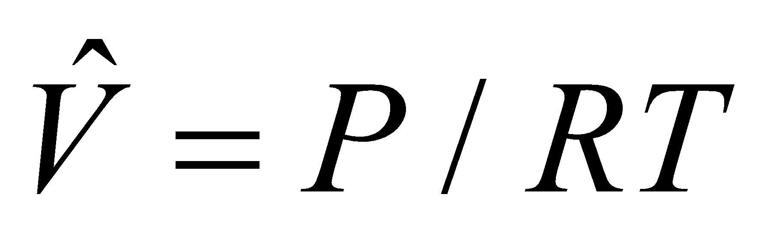
- Section 5.3b, Example 5.3-1:
  - In the solution, in the third bullet, the equation numbers are off by one; Equation 5.3-3 should be 5.3-4; Equation 5.3-4 should be 5.3-5; and Equation 5.3-5 should be 5.3-6.
  - In the solution, in the third bullet, last equation, the value should be -0.112 instead of -0.113.
  - In the solution, in the fourth bullet, the denominator in the equation should be (1.50 + 0.112) instead of (1.50 – 0.133).
- Section 5.3c: For #4 above Example 5.3-2, replace “…5.3-11 for T_{r},…” with “5.3-12 for T_{r,…”}
- Section 5.4, Test Yourself, Question 1: In the solution, the expression for T_{r} should be “T_{r} = (-190 + 273.2)/(T_{c} + 8)”.
- Section 5.4a, Test Yourself: Replace “Example 5.3-4” with “Example 5.4-2”.
- Problem 5.31: In the problem statement, the table below part (e), the units for gas evolved should be (mg CO₂), not (g CO₂).
- Problem 5.40:
  - In the problem statement, on line 5, the mole% water should be 8.1 instead of 0.81.
  - The answer should be “111.3 m³/h air”.
- Problem 5.48: In the problem statement, at the end of the first sentence, add “at 25ºC”.
  - Problem 5.50: The answer should be “(c) 9.210⁵ angstroms”
- Problem 5.59: In the problem statement in the first bullet under data, it should say “mass%” instead of “mole%”.
- Problem 5.64:
  - In the problem statement, the formula for citric acid in the chemical reaction should be C₆H₈O₇.
  - In the problem statement, the mass amounts for citric acid and sodium bicarbonate are reversed in the problem statement; it should read “citric acid (1.000 x 10³ mg) and sodium bicarbonate (1.916 x10³ mg).”
  - The answer should be “1.46 L”
CHAPTER 6
- Section 6.2: The expression for “c” above equation 6.2-1 should read “c = number of independent chemical species”
- Section 6.3, Example 6.3-3: In the solution, on the line that says “p_{H2O}=(0.3)(289 mm Hg) = 86.7 mg Hg”, it should say “mm Hg”, instead of “mg Hg”.
  - Problem 6.34: In the answer, replace 1.56 with 1.98.
  - Problem 6.62: In the answer for part (c) - the two flowrates should be shown as “3.62 mol/s of overhead vapor” and “1.03 mol/s of bottom product” - delete C4H10 and C6H14 in the units.
  - Problem 6.70: The answer should be “(b) x_{B} = 0.323, y_{B} = 0.615”
- Problem 6.70(f): In the problem statement, change x_{B} value from 0.5 to 0.55
- Problem 6.71: In the problem statement of part (a), the denominator in the equation should read “y – x_{F}” where F is subscripted
CHAPTER 7
- Section 7.6, Example 7.6-2: In the solution, the pressure identified on the flowsheet for both the inlet and outlet streams should be “1 MPa”, not “5 bar”. Under the line 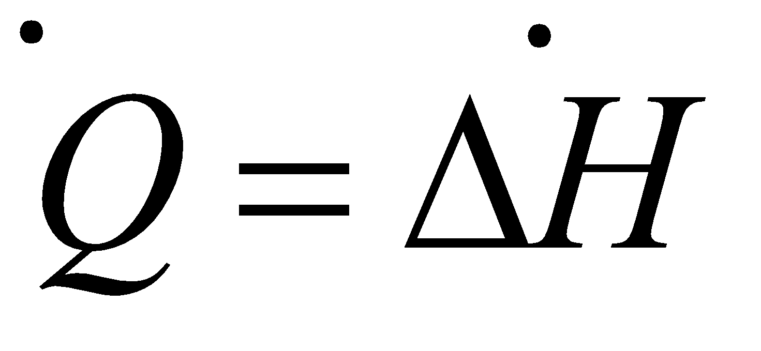, replace the text “Since the process materials are all gases and were are assuming ideal gas behavior,” with “Since the components have similar chemical structures and we can assume the mixture is ideal,”
- Problem 7.46: In the problem statement, in the stream data at the bottom of the page, the circled number 3 should have “Reflux” as the label, and the circled number 4 should have “Distillate” as the label.
- Problem 7.62: In the problem statement of part (a), replace the phrase “smooth (i.e. ignore friction)” with “frictionless”.
CHAPTER 8
- Section 8.3b, Example 8.3-3: In the solution, part (2), on line 2, it should say “can be read directly from Table B.8” (instead of Table B.9).
- Section 8.4a, Example 8.4-2: In the solution, in the calculation of ΔH for path D, the units of 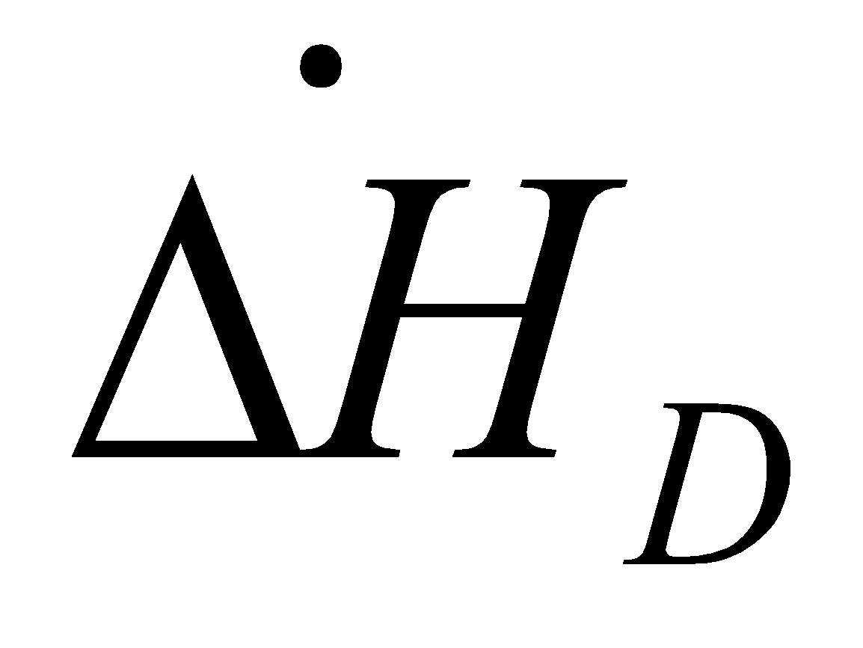 should be kJ/mol, not kJ./kg.
- Section 8.4b, Example 8.4-3:
  - In the solution of part (a), in the calculation for Chen’s Equation, the last number in the denominator (T_{c}) should be 513.2, not 213.2
  - In the solution of part (b), first line, it should say “Using the Watson’s correlation estimate:”
  - In the solution of part (b): in both the first and second equations, the denominator of the ratio should be “513.2 – 337.9” (not “513.2 – 473”), and the ratio in parentheses (both equations) should be raised to the 0.38 power.
- Problem 8.17: In the problem statement for part (c), the last part of the sentence should say, “…than is calculated in Part (b).”
- Problem 8.55: In the problem statement, first sentence, change “0.40 mJ/h” to “0.40 MJ/h”. In the second sentence of part (a), replace “If she is modeled as a closed adiabatic system at constant pressure” with “If she is modeled as a closed system at constant volume”.
- Problem 8.59: In the problem statement, the outlet conditions of the vapor and liquid streams should be 0ºC and 3 atm. Values should be corrected in the third and fourth lines of the problem statement as well as both outlet streams in the flowsheet diagram.
  - Problem 8.100: The answer should be “(b) -471 kJ/L product”
CHAPTER 9
- Section 9.3:
  - Underneath the first chemical reaction, replace -44.66 kJ/mol C₆H₆ with 48.66 kJ/mol C₆H₆ (this error only appears in some versions)
  - In the second paragraph, last 3 lines, -65.15 should be replaced by -365.15 (two instances)
- Section 9.5b, Example 9.5-3: In Footnote 7, last line, “1134” should be “1477”.
  - Problem 9.8: The answer should be for (c) instead of (b)
  - Problem 9.12: The answer should be “(c) Q = - 0.34 kW”
- Problem 9.15: In the problem statement, in the 3rd line, change “beween” to “between”
  - Problem 9.18: The answer should be “(b) -0.812 kW”
- Problem 9.24: In the problem, statement, under “Data for Diethyl Ether”, the last term in the relation for C_{p} should be 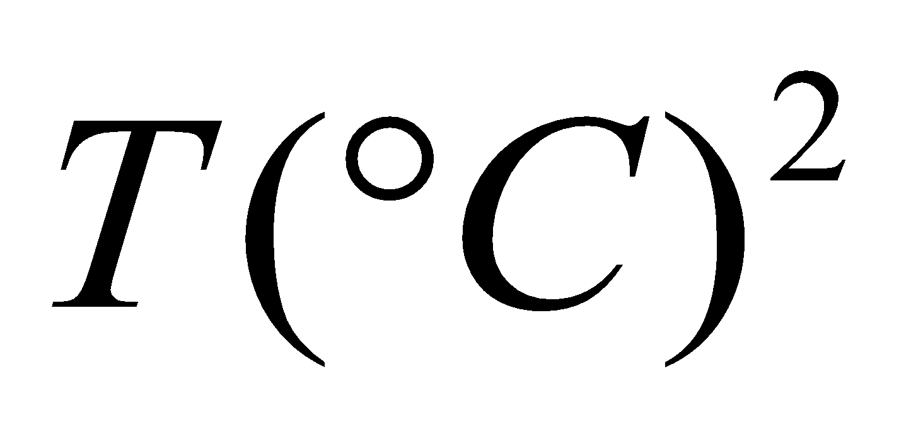 instead of T ².
  - Problem 9.26: The answer should be for (b) instead of (c)
  - Problem 9.30: The answer should be “(a) 862 kPa”
  - Problem 9.32: The answer should be “(b) 322.85ºF”
  - Problem 9.36: The answer should be “(b) 1387.5 kJ”
  - Problem 9.54: The answer should be “(d) -70,459 kJ/h”
  - Problem 9.60: The answer should be “(b) 986 kJ transferred from reactor”
- Problem 9.81: The problem statement in the equation for a₀ in part (c, has the upper limit of the sum missing in the last term. The upper limit should be 6.
CHAPTER 10
- Section 10.2-a: In the flowsheet in Example 10.2-1, the value for the flowrate of water in the input stream should be 0.05 instead of 0.5.
APPENDICES
- Table B.1:
  - Entries for formic acid:
    - Change the heat of vaporization from 22.25 to 46.3
    - Change the heat of formation of the liquid from -409.2 to -425.5
    - Change the heat of formation of the gas from -362.6 to -379.2
  - Change the entry for the heat of combustion (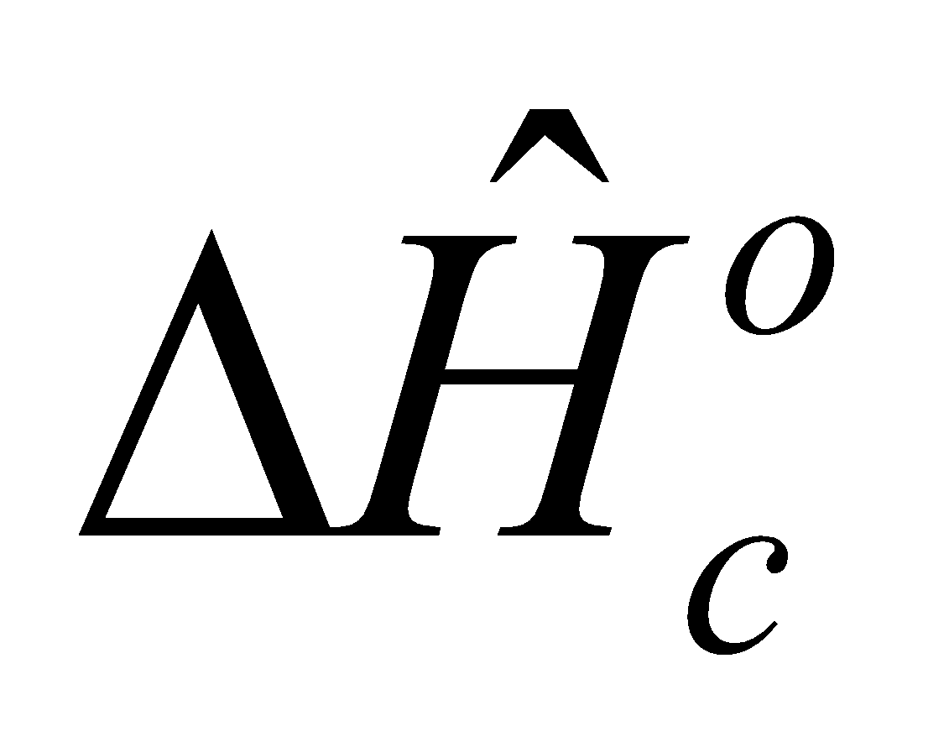) for Methyl alcohol from 726.6 to -726.6. and the specific gravity (SG) for Methyl alcohol from -0.792 to 0.792
  - Change the entry for the boiling point (T_{b}) for mercury from -356.9 to 356.9.
- Table B.3:
  - The vapor pressure of water at 18.6 C in Table B.3 should be corrected from 16.771 to 16.071.

